The 2nd International Symposium on Biomass Utilization Technologies
November 22-24, 2019， Hangzhou, China.
Please fill the information and email to isbutech@zju.edu.cn.

Name |  | Organization
Sex |  | Title
Phone Number |  | Email
Report Type:
only oral only poster both neither
Topics:
A. Chemical & Thermochemical Conversion of Biomass
B. Biological Conversion of Biomass
C. High Value-Added Biomass Utilization & Process
D. Biomass based Materials & Catalysts
E. Conversion & Capture of CO2
Other
Title of abstract
Registration fees:
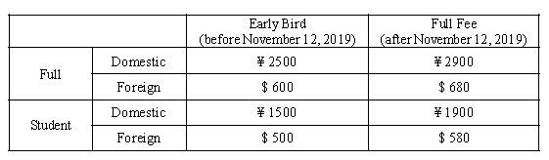
Arrival time | 2019.11.22 | Departure time | 2019.11.25
Hotel Reservation | Standard, two beds（500 RMB/Day） |  | （ ）Day
 | King size, one bed （500 RMB /Day） |  | （ ）Day
If you need the receipt,  please fill the information. |  | Organization
 |  | Tax Number
Please send the remittance document to isbutech@zju.edu.cn, so that we could assure you have paid the registration fees correctly. |  | ACCOUNT NO: 19042514040001265  BANK: AGRICULTURAL BANK OF CHINA, ZHEJIANG BRANCH, HANGHZOU ZHEDA SUB-BRANCH  NAME: HANGZHOU QIZHEN EXHIBITION SERVICE CO. ,LTD  PS: Please write down your name, organization and ISBUT 2019 in the bank note’s remark area.

